**Kitchenware and knives**

1. **Stockpot 25.5Litre Stainless Steel Chef Inox**

**Product code: TK70424**

**Product information**

18/10 Food grade Stainless Steel, 6.00mm thermal base for fast,even and efficient heat distribution

Stainless Steel 18/10

HACCP accredited

Professional strengthened handles

Intensive 3 ply, 6.0mm thermal base for fast, even and efficient heat distribution

Rolled edge for added strength, with dripless pouring rim

Suitable for all heat sources including Induction

European inspired satin finished body, inside and out, with 1.0mm guage side walls

Diameter 320mm x Height 320mm

Capacity 25.50 Litre

**Price: 3000**

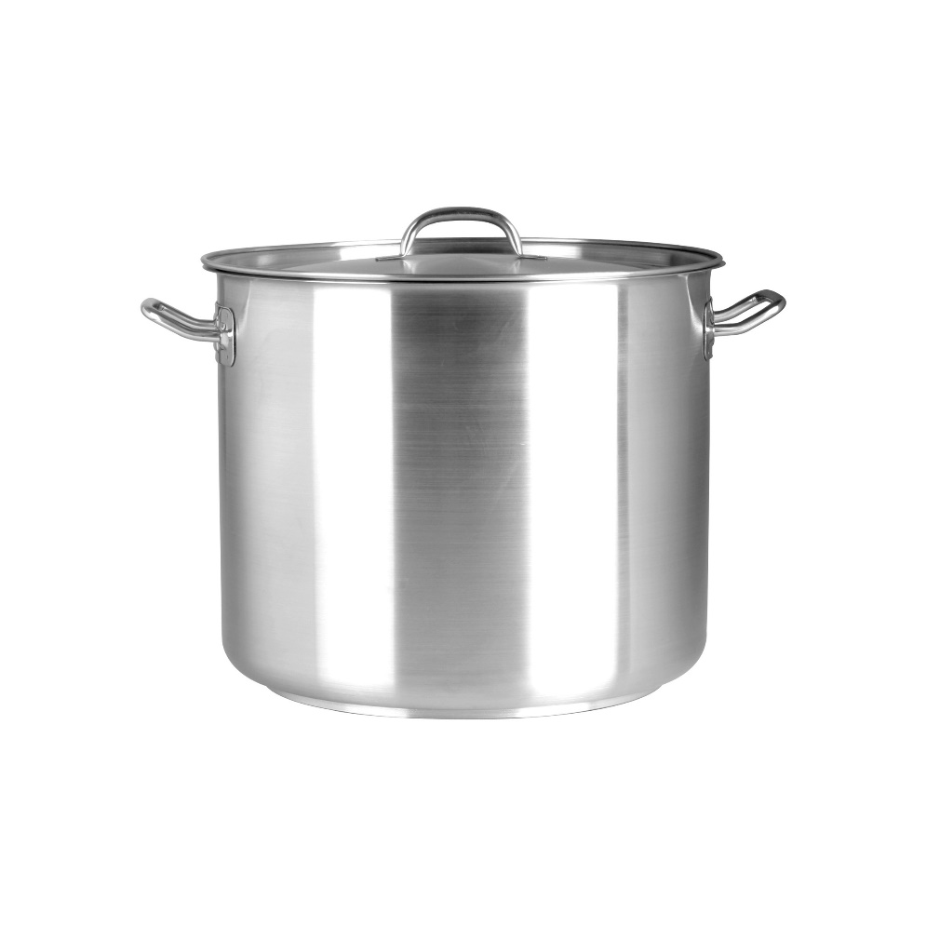

# Saucepan S/S 3Litre Chef Inox

**Product code: TK70453**

18/10 Food grade Stainless Steel, 6.00mm thermal base for fast,even and efficient heat distribution

Stainless Steel 18/10

HACCP accredited

Strengthened tubular and water tight handles, ergonomically shaped

Intensive 3 ply, 6.0mm thermal base for fast, even and efficient heat distribution

Suitable for all heat sources including Induction

European inspired satin finished body, inside and out, with 1.0mm guage side walls

Diameter 180mm x Height 120mm

**Price: 1500**

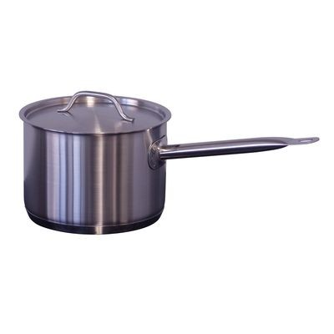

# Stockpot 70Litre Stainless Steel Chef Inox

**Product code: TK70444**

18/10 Food grade Stainless Steel, 6.00mm thermal base for fast,even and efficient heat distribution

Stainless Steel 18/10

HACCP accredited

Professional strengthened handles

Intensive 3 ply, 6.0mm thermal base for fast, even and efficient heat distribution

Rolled edge for added strength, with dripless pouring rim

Suitable for all heat sources including Induction

European inspired satin finished body, inside and out, with 1.0mm guage side walls

Diameter 450mm x Height 450mm

Capacity 70 Litre

**Price: 4000**

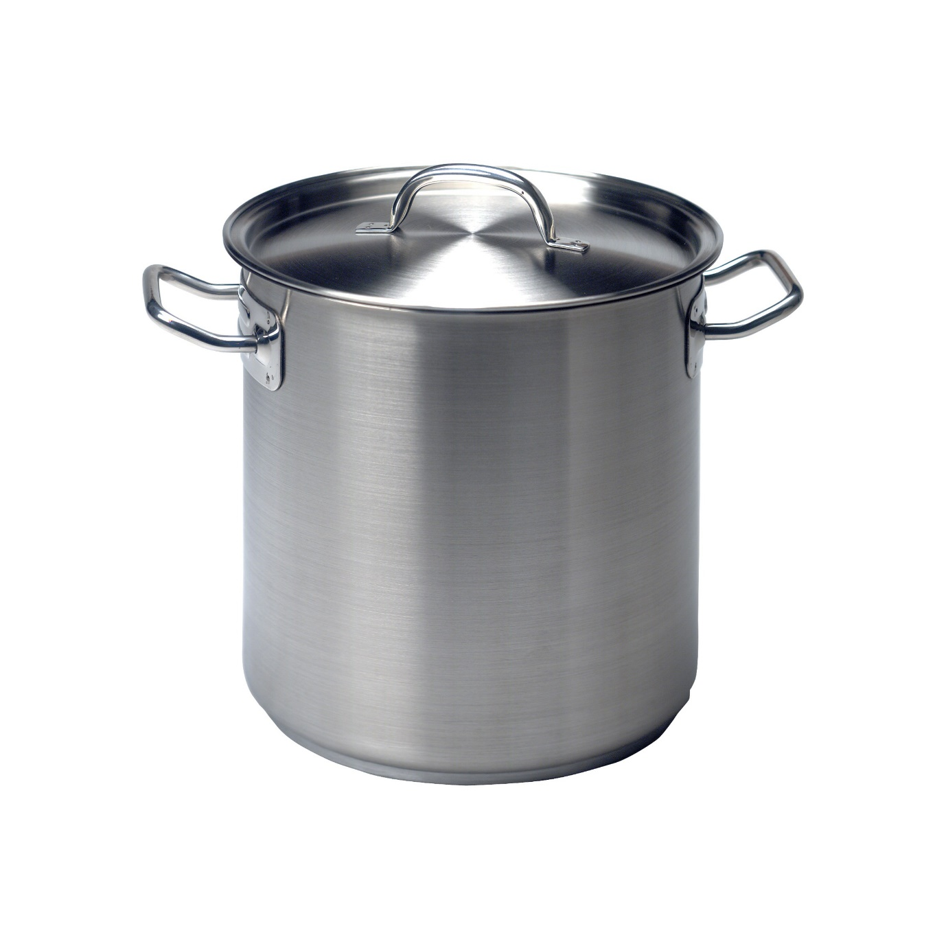

# Saute Pan Non Stick 260mm

**Product code: TK63631**

Aluminum Body Construction, Teflon Platinum, heavy duty non-stick interior for professional use

* Aluminum Body Construction
* DuPont Teflon Platinum ,Heavy duty non-stick interior for professional use
* Machine scrolled base for optimum contact with cooking surface
* Forged rivetted handles coated with heat resistant epoxy resin
* 4mm Gauge Aluminum
* Heat resistant up to 500 degrees Celsius
* **Price: 800**

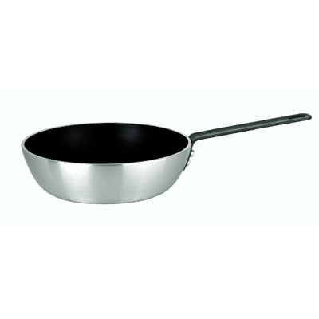

# Baking Dish Rolled Edge Aluminium 340x280mm

**Product code: KH18340**

Professional Quality Heavy Gauge Aluminium - 340 x 280 x 55mm

* Baking Dish
* Length 340mm
* Width 280mm
* Depth 55mm
* Rolled Edge
* Professional Quality Heavy Gauge Aluminium
* Made from Aluminium, A Great Heat Conductor Which Is Designed To Keep Your Food Hotter For Longer And To Get Hotter Quicker, Ideal For Those Busy Kitchens.
* Wide Edge Classic Commericial Design
* Heavy Duty
* Perfect For Baking And Roasting
* Suitable For Oven Use. (Please Note Leaving Baking Dish On Direct Flame May Leave Permanent Markings)
* Thickened Rims
* Dishwasher Safe But May Cause Discolouration, Handwash Recommended
* **Price: 400**

# Baking Dish 345x250x70mm Enamel

**Product code: WE759035**

Quality roasting dish. Dishwasher safe Colour - Black.

* Enamel quality roasting dish
* Dishwasher safe
* Colour - Black
* Size - 345mm x 250mm x 70mm
* **Price: 300**

# Cutting Board Set - 325x530x20mm

**Product code: TI48030-SET**

Set of 6 Polyethylene material cutting boards, 530mm x 325mm x 20mm

* Polyethylene
* 530mmx325mmx20mm
* Set of 6
* Brown, Blue, Red, Yellow, Green, White
* **Price: 1000**

# F.Dick Essential Professional Kit 9 Piece Box Set

**Product code: OP97001-02**

F.Dick The Real Chefs Choice! Traditionally Better Since 1778 - Made In Germany

Includes the following Items

UTILITYBOX SHARP Utility Box with Removable Tray - Black  
FD-85447-21 F.Dick Pro-Dynamic Chef’s Knife, 21cm   
FD-85039-21 F.Dick Pro-Dynamic Bread Knife, Serrated Edge, 21cm   
FD-85368-15 F.Dick Pro-Dynamic Boning Knife, Stiff, 15cm  
FD-85980-18 F.Dick Pro-Dynamic Filleting Knife, Flexible, 18cm  
FD-82620-08 F.Dick Pro-Dynamic Paring Knife, 8cm  
FD-82605-05 F.Dick Pro-Dynamic Turning Knife, 5cm  
FD-95101-17 F.Dick Pro-Dynamic Kitchen Fork, 17cm  
FD-77551-30 F.Dick EuroCut, Sharpening Steel, Regular Cut, 30cm

**Price: 2000**

# Knife Block Global

**Product code: SH79575**

Global Knife Block, Paring 80mm, Utility 110mm, Cooks 100mm & 200mm, Vegetable 140mm, Bread 220mm Knife and Stainless Steel Block

**Global Knife Block 7 Piece**

**Set includes:**

Paring 80mm,

Utility 110mm,

Cooks 130mm

Cooks 200mm,

Vegetable 140mm,

Bread 220mm Knife

Stainless Steel Block

Modern contemporary design

**Price: 1000**

# Scoop Aluminium 160x80mm

**Product code: TK66016**

Round Bottom Scoop 340ml,12OZ

* Round Bottom Scoop
* Polished Aluminium
* Ideal as scoop for bulk ice
* **Price: 250**

# Dredge S/S 285ml Coloured

**Product code: TI48005#**

Medium Hole, Stainless Steel 285ml, Assorted Colours available

* Medium Hole
* Stainless Steel
* 285ml
* Powder Coated
* Available in Red, Green, Yellow, Black, White, Blue
* **Price: 300**

# Bonzer Can Opener

**Product code: TK05000**

Benchtop H/D Can Opener with stainless steel base to mount on bench

* Benchtop H/D Can Opener
* STANDARD Model
* S/S Base Plate screws to counter top
* Can size up to 36cm
* Grey enamel finish with patented antibacterial coating
* Replaceable blade and wheel can be purchased
* **Price: 800**

